STEERING TOWARD NORMAL
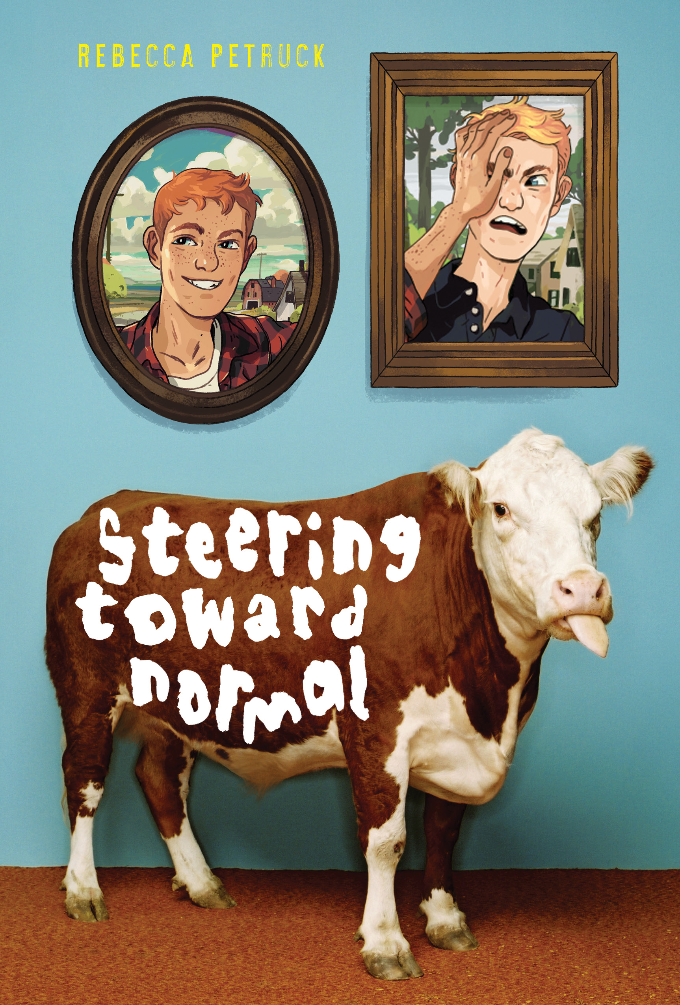 |  | At the County Fair Mad Lib  - Noun ________________________________________  - Name ________________________________________  - Verb ________________________________________  - Adjective ________________________________________  - Adjective ________________________________________  - Number ________________________________________  - Unit of Time ________________________________________  - Color ________________________________________  - Noun ________________________________________  - Adjective ________________________________________  - Verb ________________________________________  - Color ________________________________________  - Noun ________________________________________
By Rebecca Petruck (Abrams/Amulet, May 13, 2014)
www.rebeccapetruck.com

American Booksellers Association Indies Introduce New Voices selection
Spring 2014 Kids Indie Next List
VanityFair.com’s Hollywood: 10 Books We’d Like to See Made into a Movie

At the County Fair Mad Lib

Once upon a 1._____________________, a steer named 2._____________________ loved to 3._____________________. Sadly, he wasn’t very good at it because he was 4._____________________ and 5._____________________. So he practiced for 6._____________________ 7._____________________. He thought he could win a 8._____________________ 9._____________________ at the county fair, but since there was no contest for 3._____________________-ing, he entered one for 10._____________________ 11._____________________. The judges were blown away and awarded him the 12._____________________ 13._____________________ for being such a talented steer. The end.

